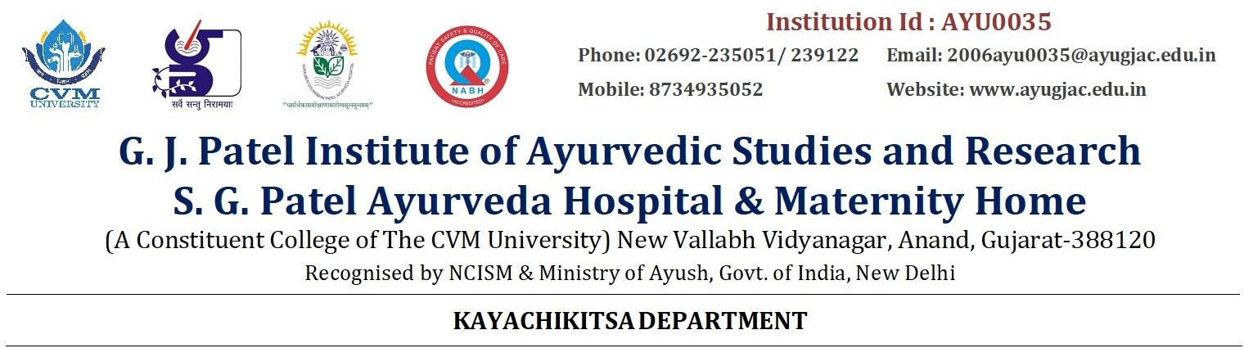

GJPIASR/KC/2024/ Date :05 .08. 2024

WEBINAR REPORT ON

Healing Hepatitis with Ayurveda: Ancient Wisdom for Modern Health Challenges

On August 3rd, 2024, the G. J. Patel Institute of Ayurvedic Studies & Research, CVM University, hosted a webinar to raise awareness about hepatitis and its treatment, attracting 354 participants, including 344 via YouTube live stream. Dr. Bharat Padhar, from the PG Department of Kayachikitsa, National Institute of Ayurveda, Jaipur, delivered the keynote address on "Healing Hepatitis with Ayurveda: Ancient Wisdom for Modern Health Challenges." He discussed Ayurvedic perspectives on hepatitis, treatment approaches, and the integration of Ayurvedic and modern medicine for holistic care. The session was well-received, providing valuable insights into applying ancient Ayurvedic wisdom to contemporary health challenges. The event was organized by the Department of Kayachikitsa, contributing to the broader understanding of Ayurveda's role in modern healthcare.

**Dr.Manchak V Kendre**

**Prof & HOD**

**Department of Kayachikitsa**

